Automate a Flipkart website

**Source code:**

**Github link:**

<https://github.com/kalviyarasi/Practise_project/tree/master/Phase5/Flipkart>

**Video link:** <https://drive.google.com/file/d/1x_rUu2jf6VpvkDAAGajokf9_QXeVWYLD/view?usp=drivesdk>

**Write ups:**

* Create a project in spring tool suite. Add the necessary jar files like selenium to automate the website.
* Run the test ng file.
* Chrome browser opens the Flipkart website and searches for Iphone 13 in the search bar.
* Now it automatically scrolls down to see the list of suggested items.
* This is tested using another browser other then chrome to verify.
* Now the website is automated using edge browser.
* All the test cases have been passed.

**Screenshots:**

1)Run the TestNg file, chrome automatically opens the flipkart website.

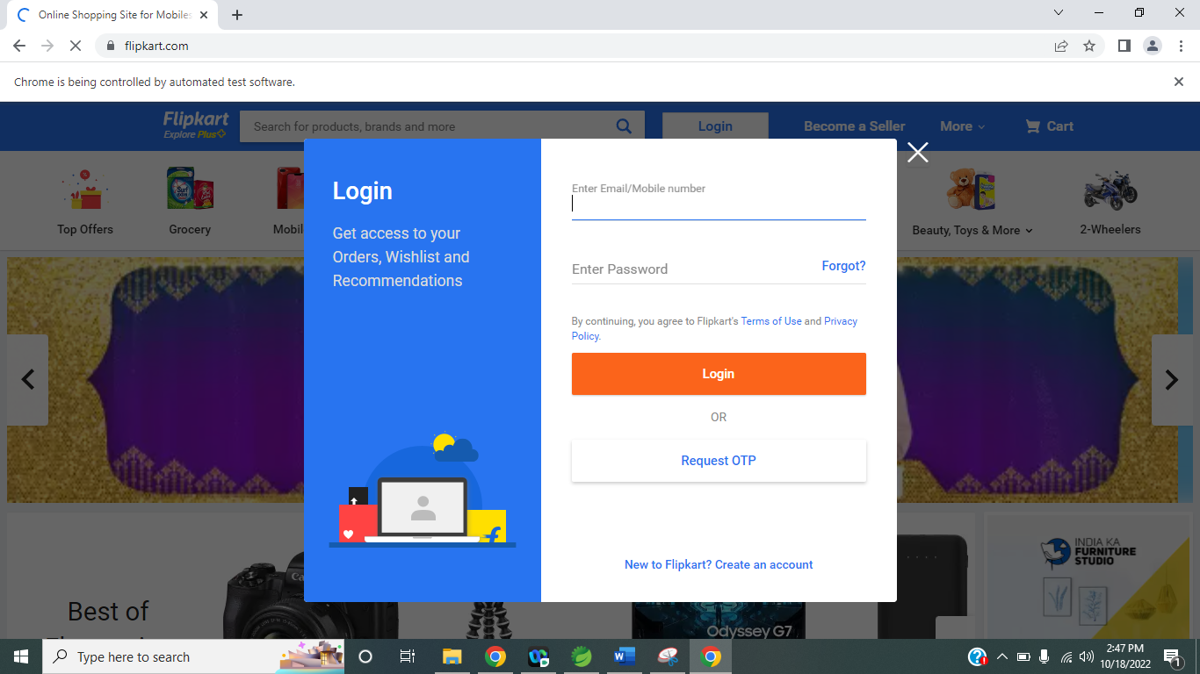

2)In the search box, it automatically searches for iPhone 13.

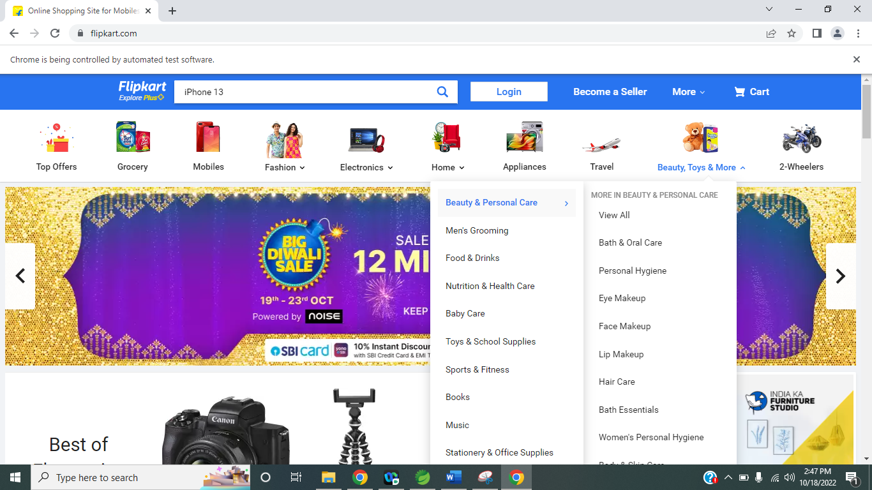

3)It automatically scrolls down to see the list of suggested items.

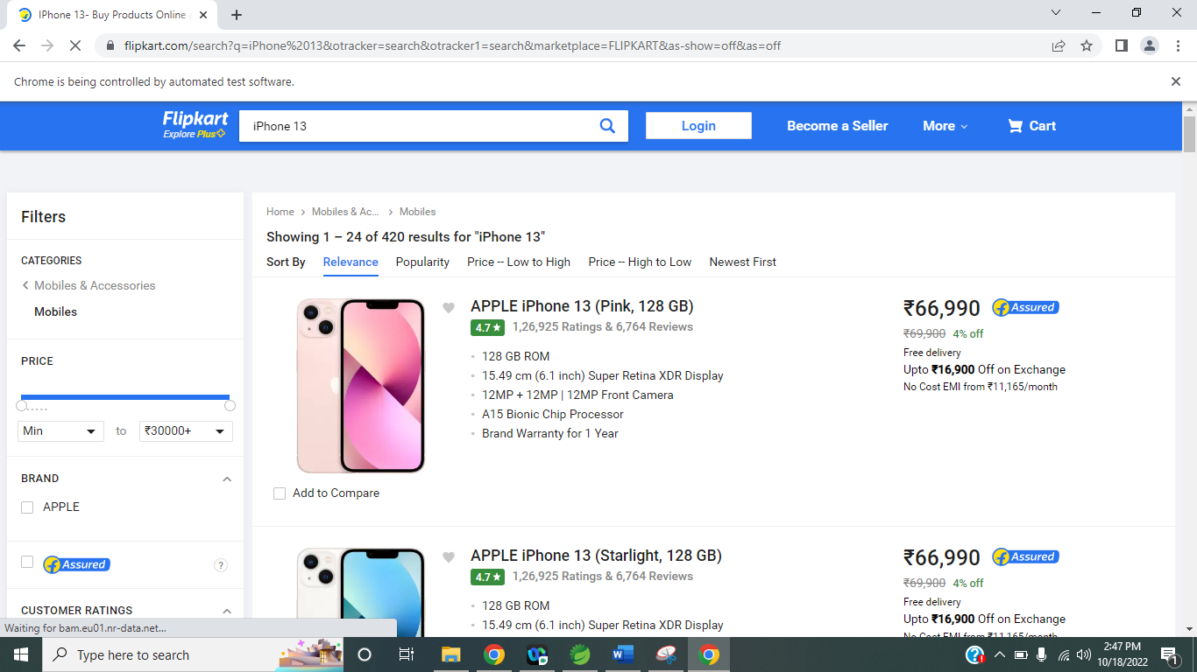

4)It scrolls down till the end and look for specific option

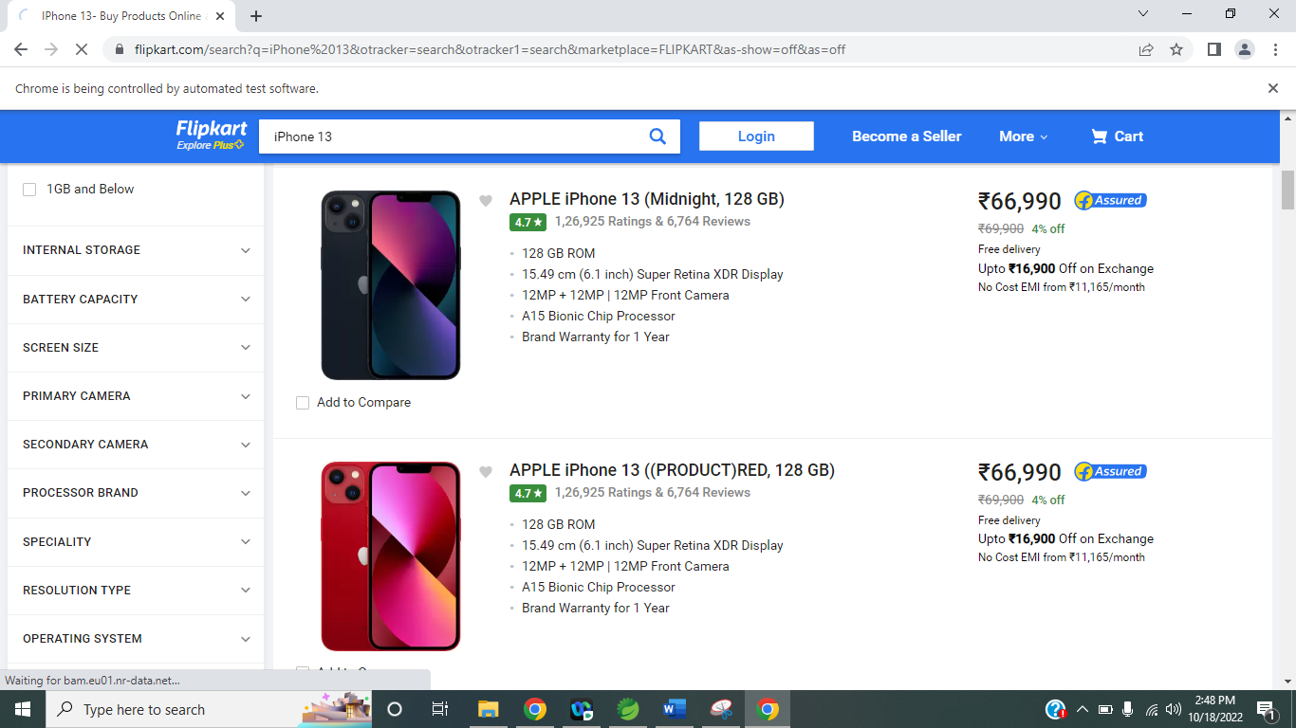

5)Now the chrome driver minimizes automatically

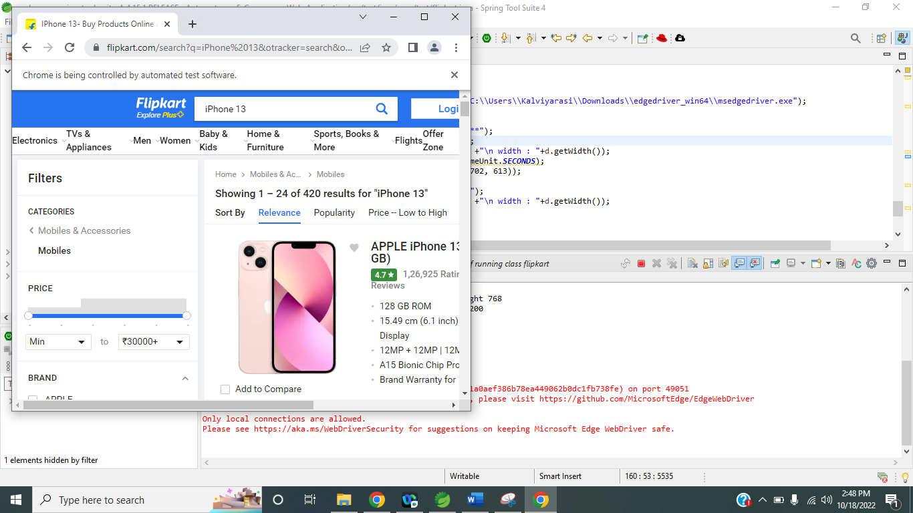

6) Now the automation is tested using edge browser

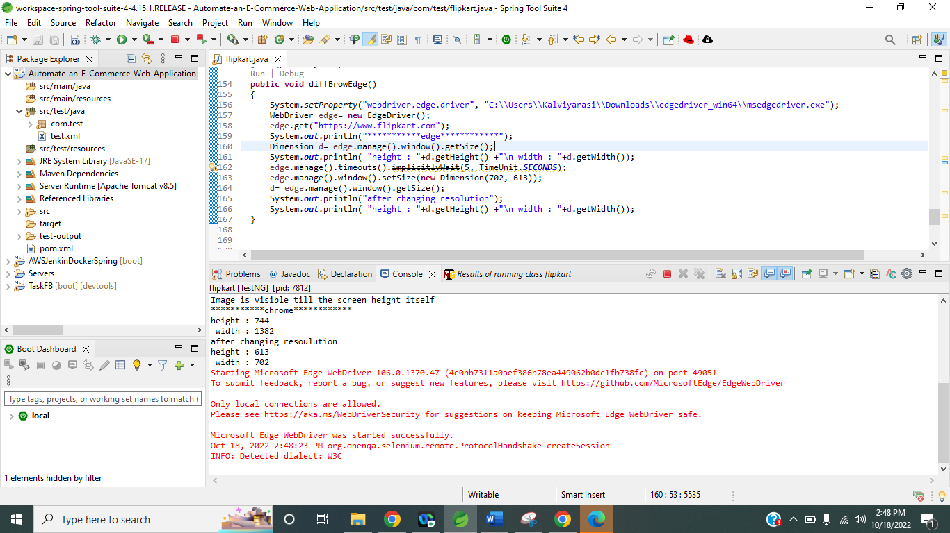

7) The website now opens through edge browser

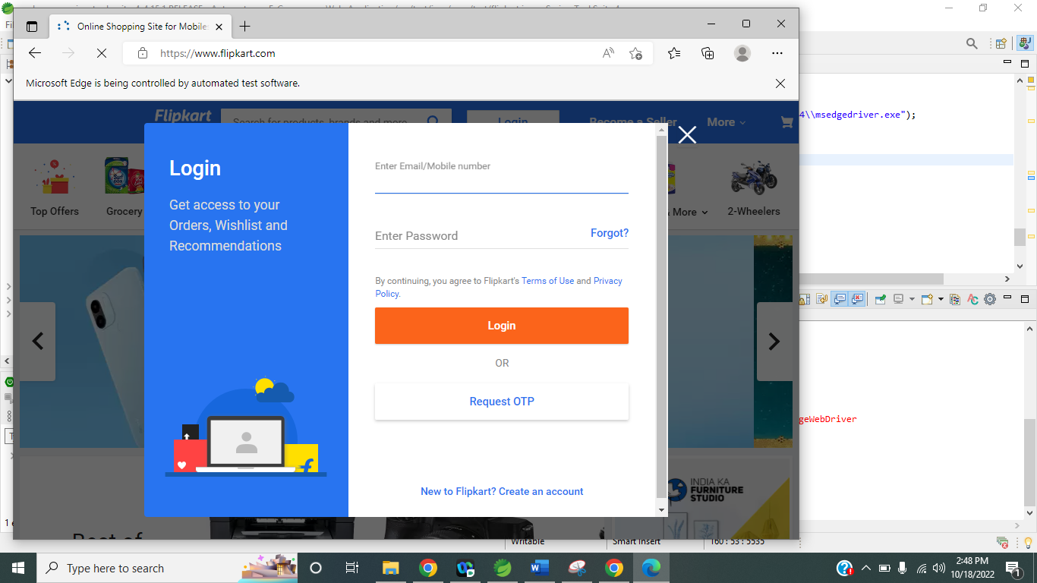

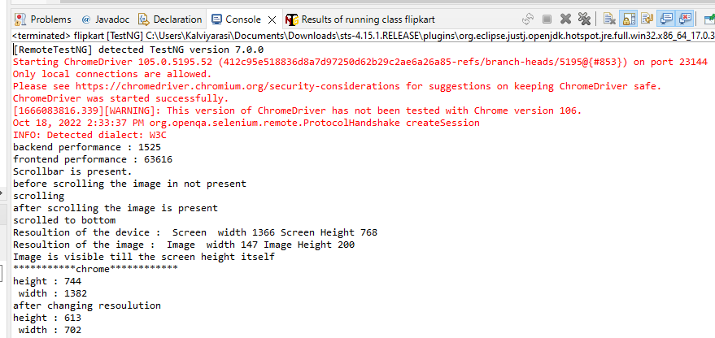

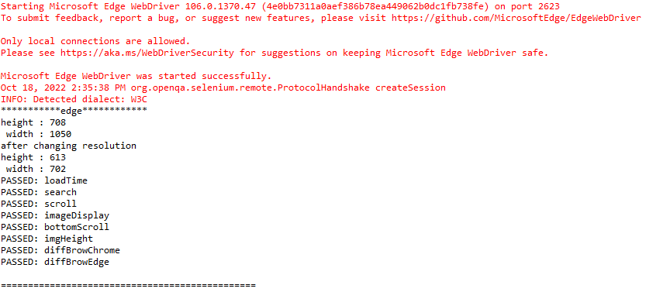

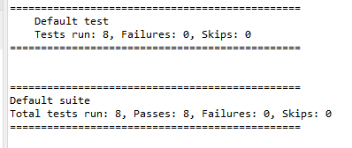

All the test case has been passed.